Refer solution to assignment “Nalanda_CPP_Assignment 3a”. Extend it to add support for below requirements.

1. Add a friend function to access and display employee attributes of an employee.

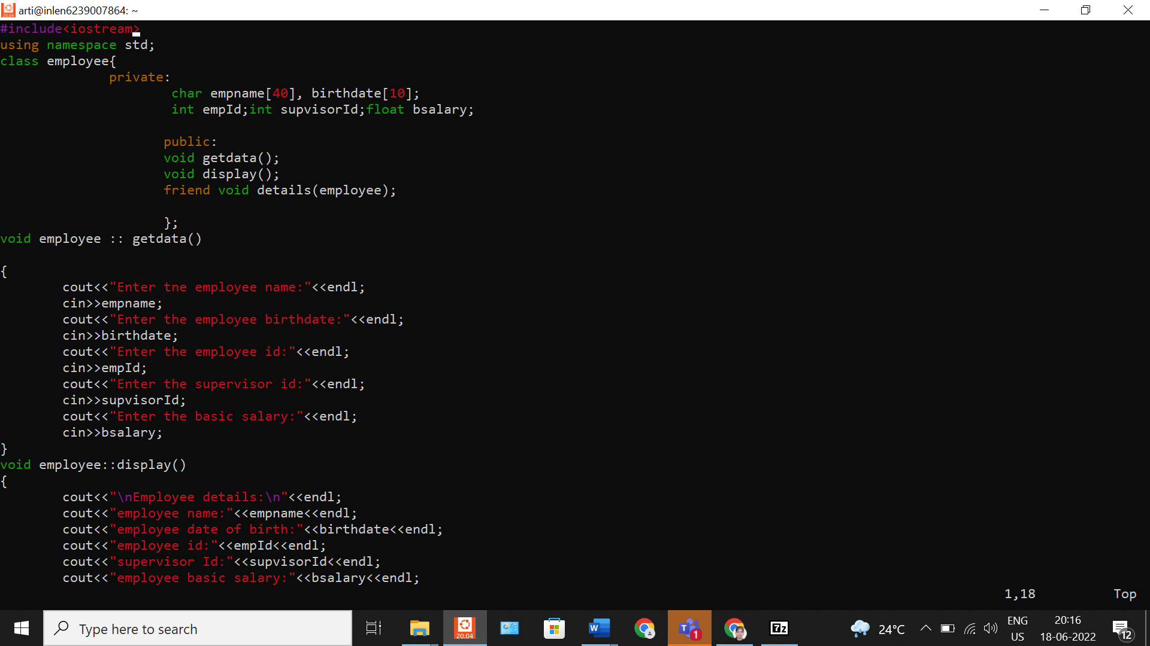

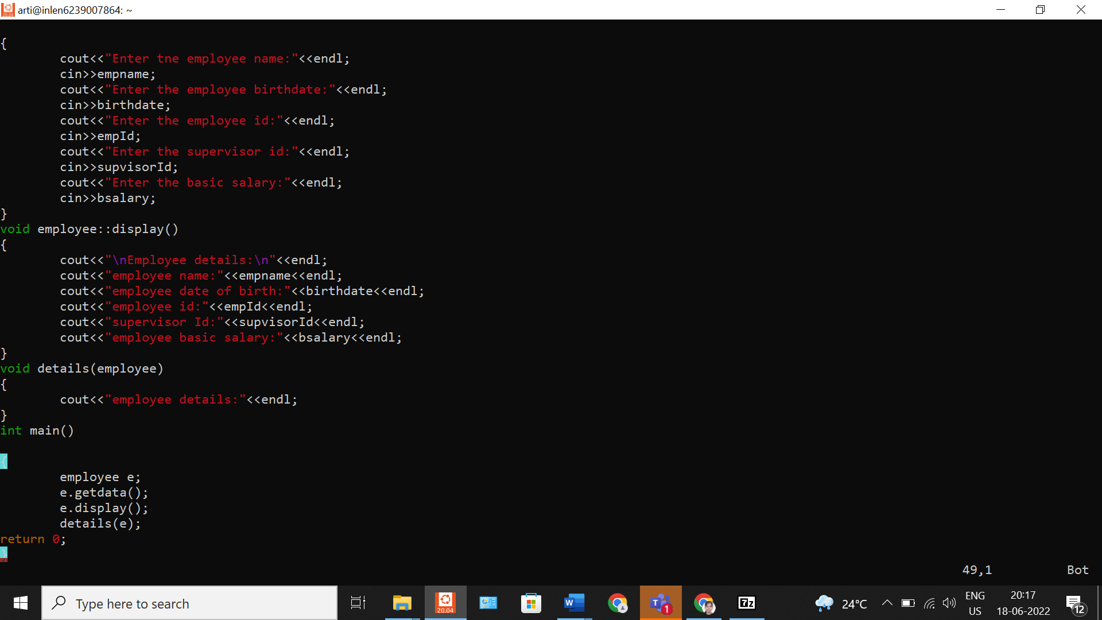

**OUTPUT**

